**CARIBBEAN ISLAND REST**

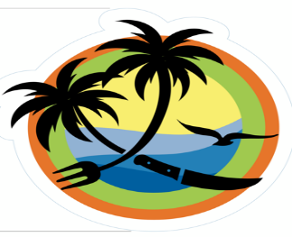

**LOCALIDAD / LOCATED**

**318 9TH ST N**

**NAPLES FL, 34102**

**(239) 529-6733**

**E-mail: XXXXXXXXXX**

**ABIERTO/OPEN (6 DIAS / 6 DAYS)**

**10:00 AM- 09:00 PM**

**MENU**

POLLO / CHICKEN

POLLO GUISADO (CHICKEN STEW)

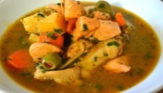

POLLO AL HORNO (BAKED CHICKEN)

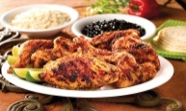

FILETE A LA PLACHA (GRILLED FILLET)

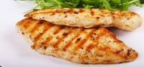

ALITAS (CHICKEN WINGS)

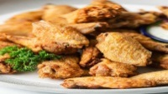

CARNE ROJA / RED MEAT

CHURRASCO (STEAK)

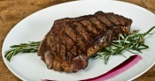

CARNE GUISADA (PEPPER STEAK)

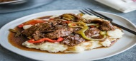

CERDO / PORK

PERNIL ASADO (ROASTED PORK)

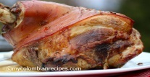

CARNE FRITA (FRIED MEAT)

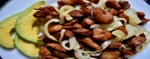

CHULETA (CHOP)

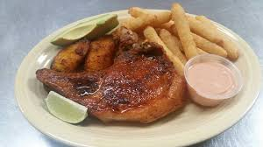

SEA FOOD (FRIED/BAKED

TILAPIA (TILAP)

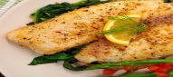

SALMON

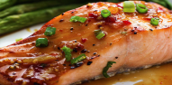

PESCADO (FISH)

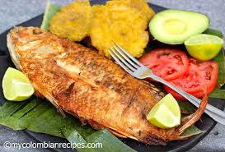

CAMARONES (SHRIMP)

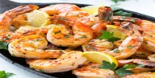

ACOMPAÑANTES/ SIDES

ARROZ/RICE

BLANCO /WHITE

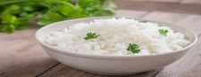

VEGETALES MIXTOS (MIXED VEGETABLE RICE)

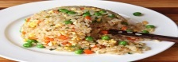

ARROZ CON HABICHUELA (RICE W/ BEANS)

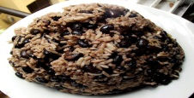

ARROZ CON GANDULES (RICE W/ PEAS)

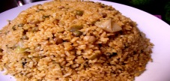

HABICHUELAS GUISADAS / BEAN

ROJAS (RED)

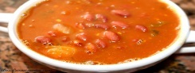

NEGRAS (BLACK)

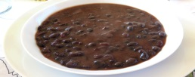

PASTA

LASAGNA

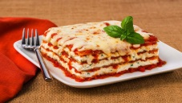

SPAGHETTI (CHICKEN ALFREDO)

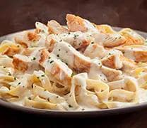

VIANDA/YAMS

MANGU (MAN GOOD) (GREEN PLANTAIN)

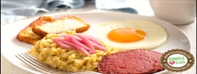

SANCOCHO (SOUP)

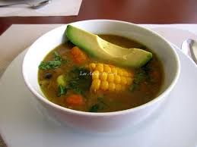

YUCA(CASSAVA)

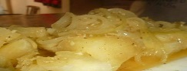

TOSTONES

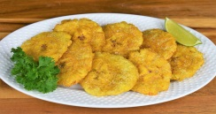

PLATANOS MADURO/YELLOW PLANTAIN

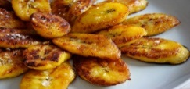

Read phoneticall

Dictionary - [View detailed dictionary](http://www.google.com/dictionary?source=translation&hl=en&q=&langpair=)

1. **verb**
   1. evitar
   2. impedir
   3. excusar
   4. caucionar

ENSALADA/ SALAD

VERDE (GARDEN)

PAPA MAJADA (MASH POTATO)

CODITO (MACARONI)

Listen

HAMBURGER W/FRENCH FRIED

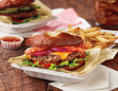

CHICKEN NUGGETTS W/ FRENCH FRIED

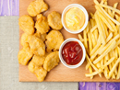

POSTRE / DESSERT

FLAN (VANILLA, QUESO)



QUESITOS (puff pastry with cheese)



Tarta de queso (CHESSE CAKE)

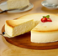

PASTEL (CAKE)



BEBIDAS / BEVERAGES

JUGOS NATURALES

NARANJA(ORANGE)

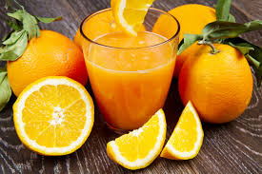

MANGO

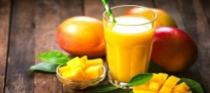

MORIR SOÑANDO(TO DIE DREAMING)

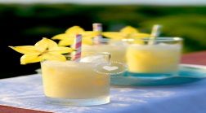

COCONUT WATER

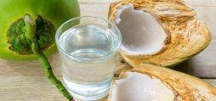

CAÑA DULCE (SUGAR CANE)

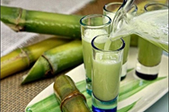

NUESTRA ESPECIALIDAD

MANJU (MAN GOOD)

MORIR SOÑADO (TO DIE DREAMING)

JUGO DE CAÑA (SUGAR CANE)

DINE IN, TAKE OUT, DELIVERY

